|  |  |
| --- | --- |
| Patient Name Sex Age DOB | MRN  NHS No |

|  |  |  |
| --- | --- | --- |
| DIAGNOSTIC | PROCEDURE (NHS) | PROCEDURE (PRIVATE) |

DIAGNOSTIC CODING

INPUT

|  |  |  |  |  |  |  |
| --- | --- | --- | --- | --- | --- | --- |
| **DIAGNOSES**  **In order of importance** | | **DATE** | **ICD 10**  **BROWSE /ADD TO LIST** | **SIGNER** | **COMMENTS**  For injuries, note the cause  For infections, note the organism  For overdoses, note the drug | **SNOMED CODE** |
| 1. Start typing | **X** |  |  |  |  |  |
| 2. Start typing | **X** |  |  |  |  |  |
| 3. Start typing | **X** |  |  |  |  |  |
| Add row | **+** |  |  |  |  |  |
| **CO-MORBIDITIES** |  |  | **ICD 10** |  |  |  |
| 1. Start typing | **X** |  |  |  |  |  |
| 2. Start typing | **X** |  |  |  |  |  |
| 3. Start typing | **X** |  |  |  |  |  |
| Add row | **+** |  |  |  |  |  |
| **CONCURRENT DIAGNOSES IMPACTING LENGTH OF STAY** |  |  | **ICD 10** |  |  |  |
| 1. Start typing | **X** |  |  |  |  |  |
| 2. Start typing | **X** |  |  |  |  |  |
| 3. Start typing | **X** |  |  |  |  |  |
| Add row | **+** |  |  |  |  |  |

IN PROGRESS Complete Save CANCEL

|  |  |  |
| --- | --- | --- |
| NOTES | UNDERSTANDING CODING | CLOSE |

**CODING**

|  |  |
| --- | --- |
| Patient Name Sex Age DOB | MRN  NHS No |

DIAGNOSTIC CODING

INPUT

|  |  |  |  |  |  |  |
| --- | --- | --- | --- | --- | --- | --- |
| **DIAGNOSES**  **In order of importance** | | **DATE** | **ICD 10**  **BROWSE /ADD TO LIST** | **SIGNER** | **COMMENTS**  For injuries, note the cause  For infections, note the organism  For overdoses, note the drug | **SNOMED CODE** |
| 1. Start typing | **X** |  |  |  |  |  |
| 2. Start typing | **X** |  |  |  |  |  |
| 3. Start typing | **X** |  |  |  |  |  |
| Add row | **+** |  |  |  |  |  |
| **CO-MORBIDITIES** |  |  | **ICD 10** |  |  |  |
| 1. Start typing | **X** |  |  |  |  |  |
| 2. Start typing | **X** |  |  |  |  |  |
| 3. Start typing | **X** |  |  |  |  |  |
| Add row | **+** |  |  |  |  |  |
| **CONCURRENT DIAGNOSES IMPACTING LENGTH OF STAY** |  |  | **ICD 10** |  |  |  |
| 1. Start typing | **X** |  |  |  |  |  |
| 2. Start typing | **X** |  |  |  |  |  |
| 3. Start typing | **X** |  |  |  |  |  |
| Add row | **+** |  |  |  |  |  |

IN PROGRESS Complete Save CANCEL

**SEARCH POP UP**

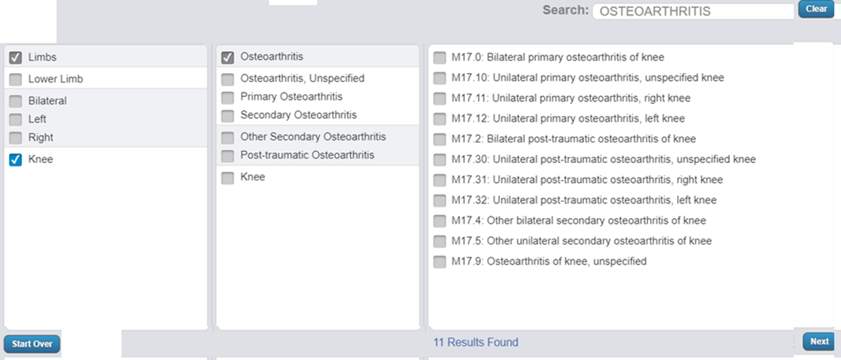

OUTPUT

|  |  |  |  |  |  |
| --- | --- | --- | --- | --- | --- |
| **DIAGNOSES - In order of importance** | **DATE** | **ICD 10** | **SIGNER** | **COMMENTS** | **SNOMED CODE** |
| 1. |  |  |  |  |  |
| 2. |  |  |  |  |  |
| 3. |  |  |  |  |  |
| **CO-MORBIDITIES** |  | **ICD 10** |  |  |  |
| 1. |  |  |  |  |  |
| 2. |  |  |  |  |  |
| 3. |  |  |  |  |  |
| **CONCURRENT DIAGNOSES IMPACTING LENGTH OF STAY** |  | **ICD 10** |  |  |  |
| 1. |  |  |  |  |  |
| 2. |  |  |  |  |  |
| 3. |  |  |  |  |  |

PROCEDURE CODING (NHS)

INPUT

|  |  |  |  |  |  |
| --- | --- | --- | --- | --- | --- |
| **SURGICAL PROCEDURES** |  | **DATE** | **OPCS-4**  **BROWSE / ADD TO LIST** | **SIGNER** | **COMMENTS** |
| 1. Start typing | **X** |  |  |  |  |
| 2. Start typing | **X** |  |  |  |  |
| 3. Start typing | **X** |  |  |  |  |
|  | **+** |  |  |  |  |
| **ANY PROCEDURES DONE ON THE WARD incl.by another clinical team** |  | **DATE** | **OPCS-4** |  |  |
| 1. Start typing | **X** |  |  |  |  |
| 2. Start typing | **X** |  |  |  |  |
| 3. Start typing | **X** |  |  |  |  |
|  | **+** |  |  |  |  |
| **RELEVANT INVESTIGATIONS IN HOSPITAL** |  | DATE | **OPCS-4** |  |  |
| 1. Start typing | **X** |  |  |  |  |
| 2. Start typing | **X** |  |  |  |  |
| 3. Start typing | **X** |  |  |  |  |
|  | **+** |  |  |  |  |

IN PROGRESS Complete Save CANCEL

OUTPUT

|  |  |  |  |  |
| --- | --- | --- | --- | --- |
| **SURGICAL PROCEDURES** | **DATE** | **OPCS-4** | **SIGNER** | **COMMENTS** |
| 1. |  |  |  |  |
| 2. |  |  |  |  |
| 3. |  |  |  |  |
| **ANY PROCEDURES DONE ON THE WARD incl.by another clinical team** | **DATE** | **OPCS-4** |  |  |
| 1. |  |  |  |  |
| 2. |  |  |  |  |
| 3. |  |  |  |  |
| **RELEVANT INVESTIGATIONS IN HOSPITAL** |  | **OPCS-4** |  |  |
| 1. |  |  |  |  |
| 2. |  |  |  |  |
| 3. |  |  |  |  |

PROCEDURE CODING (PRIVATE SECTOR)

INPUT

|  |  |  |  |  |  |
| --- | --- | --- | --- | --- | --- |
| **SURGICAL PROCEDURES** |  | **DATE** | **CCSD CODE**  **BROWSE / ADD TO LIST** | **SIGNER** | **COMMENTS** |
| 1. Start typing | **X** |  |  |  |  |
| 2. Start typing | **X** |  |  |  |  |
| 3. Start typing | **X** |  |  |  |  |
|  | **+** |  |  |  |  |
| **ANY PROCEDURES DONE ON THE WARD incl.by another clinical team** |  | **DATE** | **CCSD CODE** |  |  |
| 1. Start typing | **X** |  |  |  |  |
| 2. Start typing | **X** |  |  |  |  |
| 3. Start typing | **X** |  |  |  |  |
|  | **+** |  |  |  |  |
| **RELEVANT INVESTIGATIONS IN HOSPITAL** |  |  | **CCSD CODE** |  |  |
| 1. Start typing | **X** |  |  |  |  |
| 2. Start typing | **X** |  |  |  |  |
| 3. Start typing | **X** |  |  |  |  |
|  | **+** |  |  |  |  |

IN PROGRESS Complete Save CANCEL

OUTPUT

|  |  |  |  |  |
| --- | --- | --- | --- | --- |
| **SURGICAL PROCEDURES** | **DATE** | **CCSD CODE** | **SIGNER** | **COMMENTS** |
| 1. |  |  |  |  |
| 2. |  |  |  |  |
| 3. |  |  |  |  |
| **ANY PROCEDURES DONE ON THE WARD incl.by another clinical team** | **DATE** | **CCSD CODE** |  |  |
| 1. |  |  |  |  |
| 2. |  |  |  |  |
| 3. |  |  |  |  |
| **RELEVANT INVESTIGATIONS IN HOSPITAL** |  | **CCSD CODE** |  |  |
| 1. |  |  |  |  |
| 2. |  |  |  |  |
| 3. |  |  |  |  |

**NOTES**

|  |
| --- |
| Avoid the use of new or ambiguous abbreviations (e.g. “m.s.” could mean multiple sclerosis or mitral stenosis. (If a clear diagnosis has not been reached, make sure you detail main symptoms in the notes or discharge summary. Any “query” diagnoses, or diagnoses preceded by a “?” cannot be coded by clinical coding staff. If histology is awaited for a definitive diagnosis, note this down. Get a senior member of medical staff to confirm or validate these diagnoses and procedures. Best practice is to summarise all of these as the last (discharge) entry in the notes. Remember: clinical coding staff are not allowed to make any clinical inferences.) |

|  |
| --- |
| Appendix 1 - List of mandatory comorbidities Condition  Cerebrovascular diseases  Hemiplegia  Alzheimer’s disease including dementia in Alzheimer’s disease  Dementia including dementia in Alzheimer’s disease  Epilepsy  Multiple Sclerosis  Developmental delay including learning difficulties and learning disability  Autism  Dysphasia  Anxiety disorders including anxiety  Depressive disorders including depression and bipolar disorder  Psychosis and psychotic disorders including schizophrenia, schizotypal and delusional disorders  Personal history of self-harm  Hypertension  Ischaemic heart disease  Heart Failure  Left Ventricular Failure  Mitral Valve disease  Congestive cardiac failure  Current anti-coagulant therapy Personal history of anti-coagulant therapy  Presence of cardiac pacemaker  Chronic obstructive pulmonary disease /Chronic obstructive airways disease  Chronic bronchitis  Asthma  Emphysema  Respiratory failure  Diabetes Mellitus  Rheumatoid arthritis  Eating disorders  Dysphagia (difficulty in swallowing)  Abnormal liver function test (in the absence of any underlying cause)  Renal failure  Chronic kidney diseases including chronic tubulo-interstitial nephritis, small kidney(s) and polycystic kidney(s)  Urinary retention  Living Alone  Elderly / Geriatric falls  Current smoker  Alcohol abuse  Drug abuse  Registered Blind  Severe or profound hearing loss  • Personal hx of stroke  • Person hx of other physical trauma  • Presence of PEG  • Personal hx of non-compliance  • Personal hx of TIA  • Unemployment • Homelessness • Dependence on wheelchair  • Personal Hx of Neoplasm |

DESIGN

MONTSERRAT LIGHT FONT for body

MONTSERRAT REGULAR for headings



